https://teenhealth.us/brand-partner
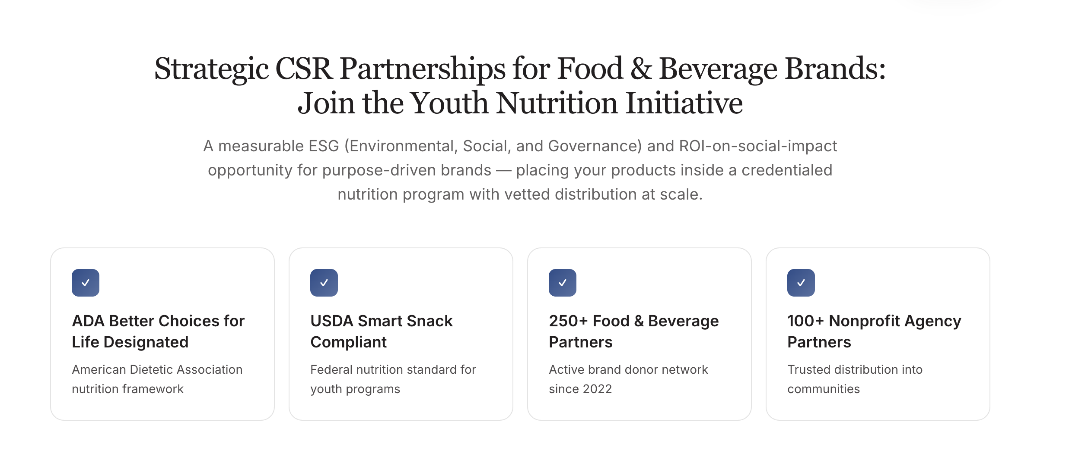
We need to change this up…..
- Delete CSR from the first sentence.
- Replace this with the sentence below the second sentence.
A social impact opportunity for purpose-driven brands. Placing your products inside nutrition programs with vetted distribution at scale.

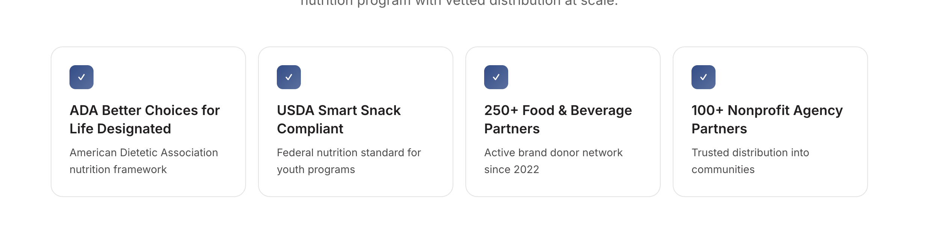
Just delete this section….

https://teenhealth.us/our-work
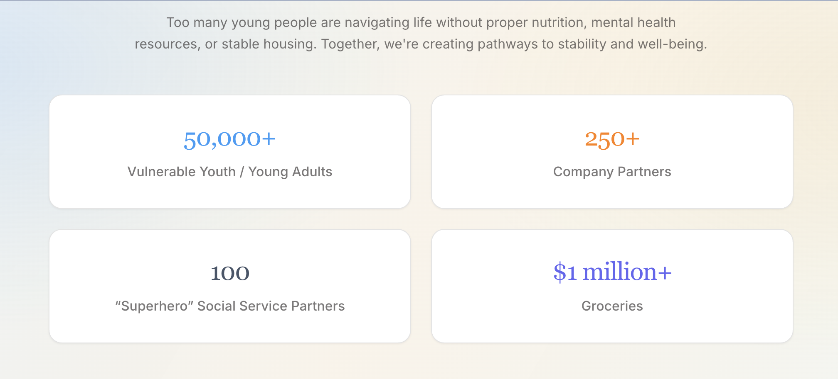
Let’s make superhero section 100+
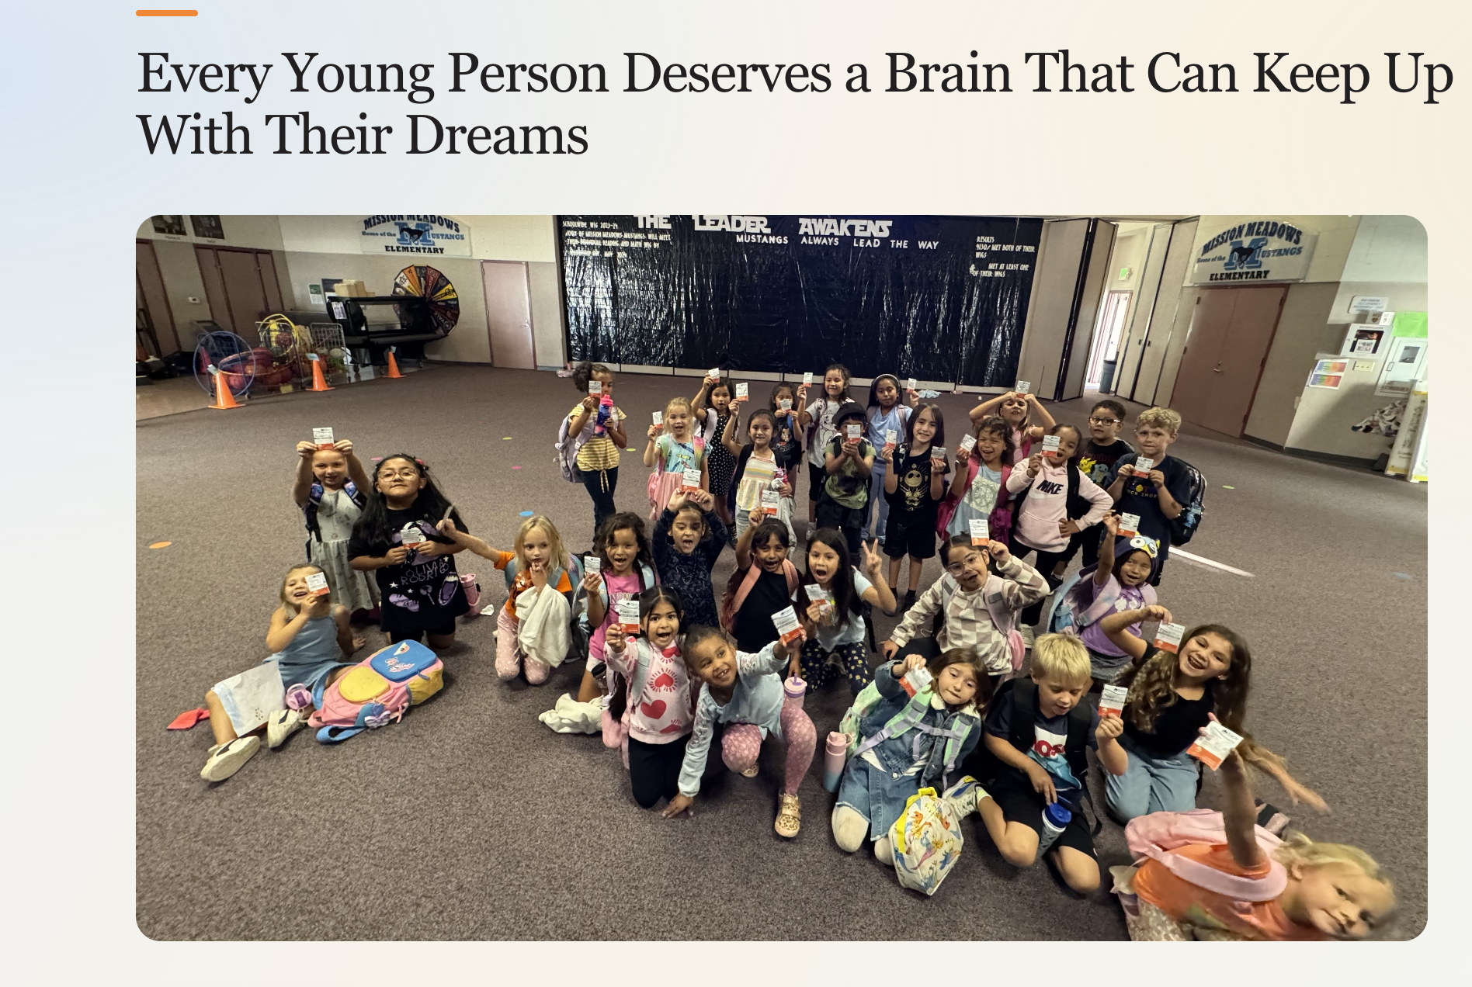
Add the name of the school- you can start on the bottom left.

https://teenhealth.us/youth-nutrition-initiative
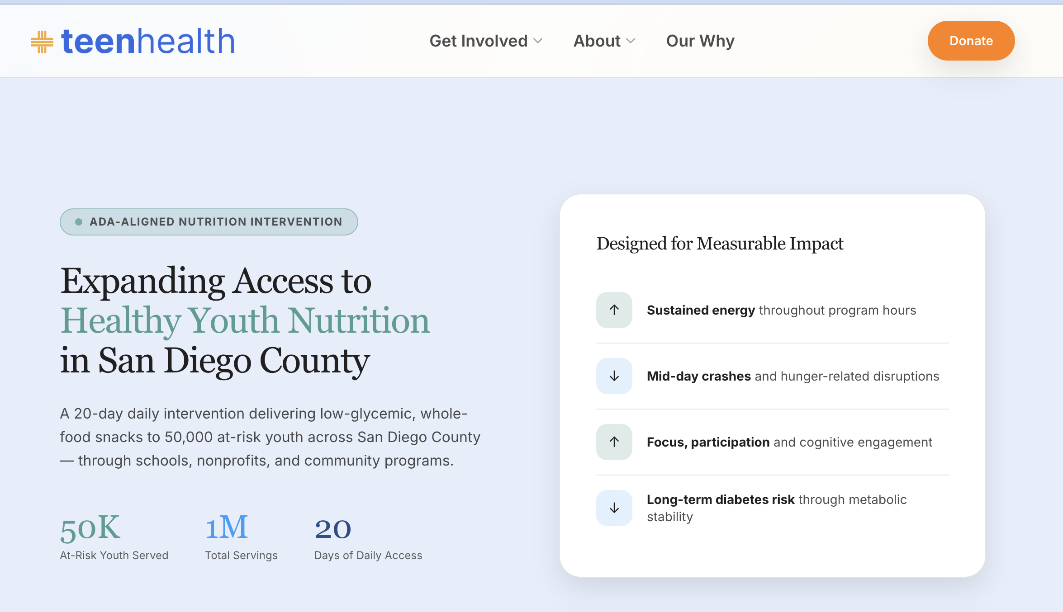
Can you change all references to San Diego County -to Southern California.

https://teenhealth.us/how-we-work
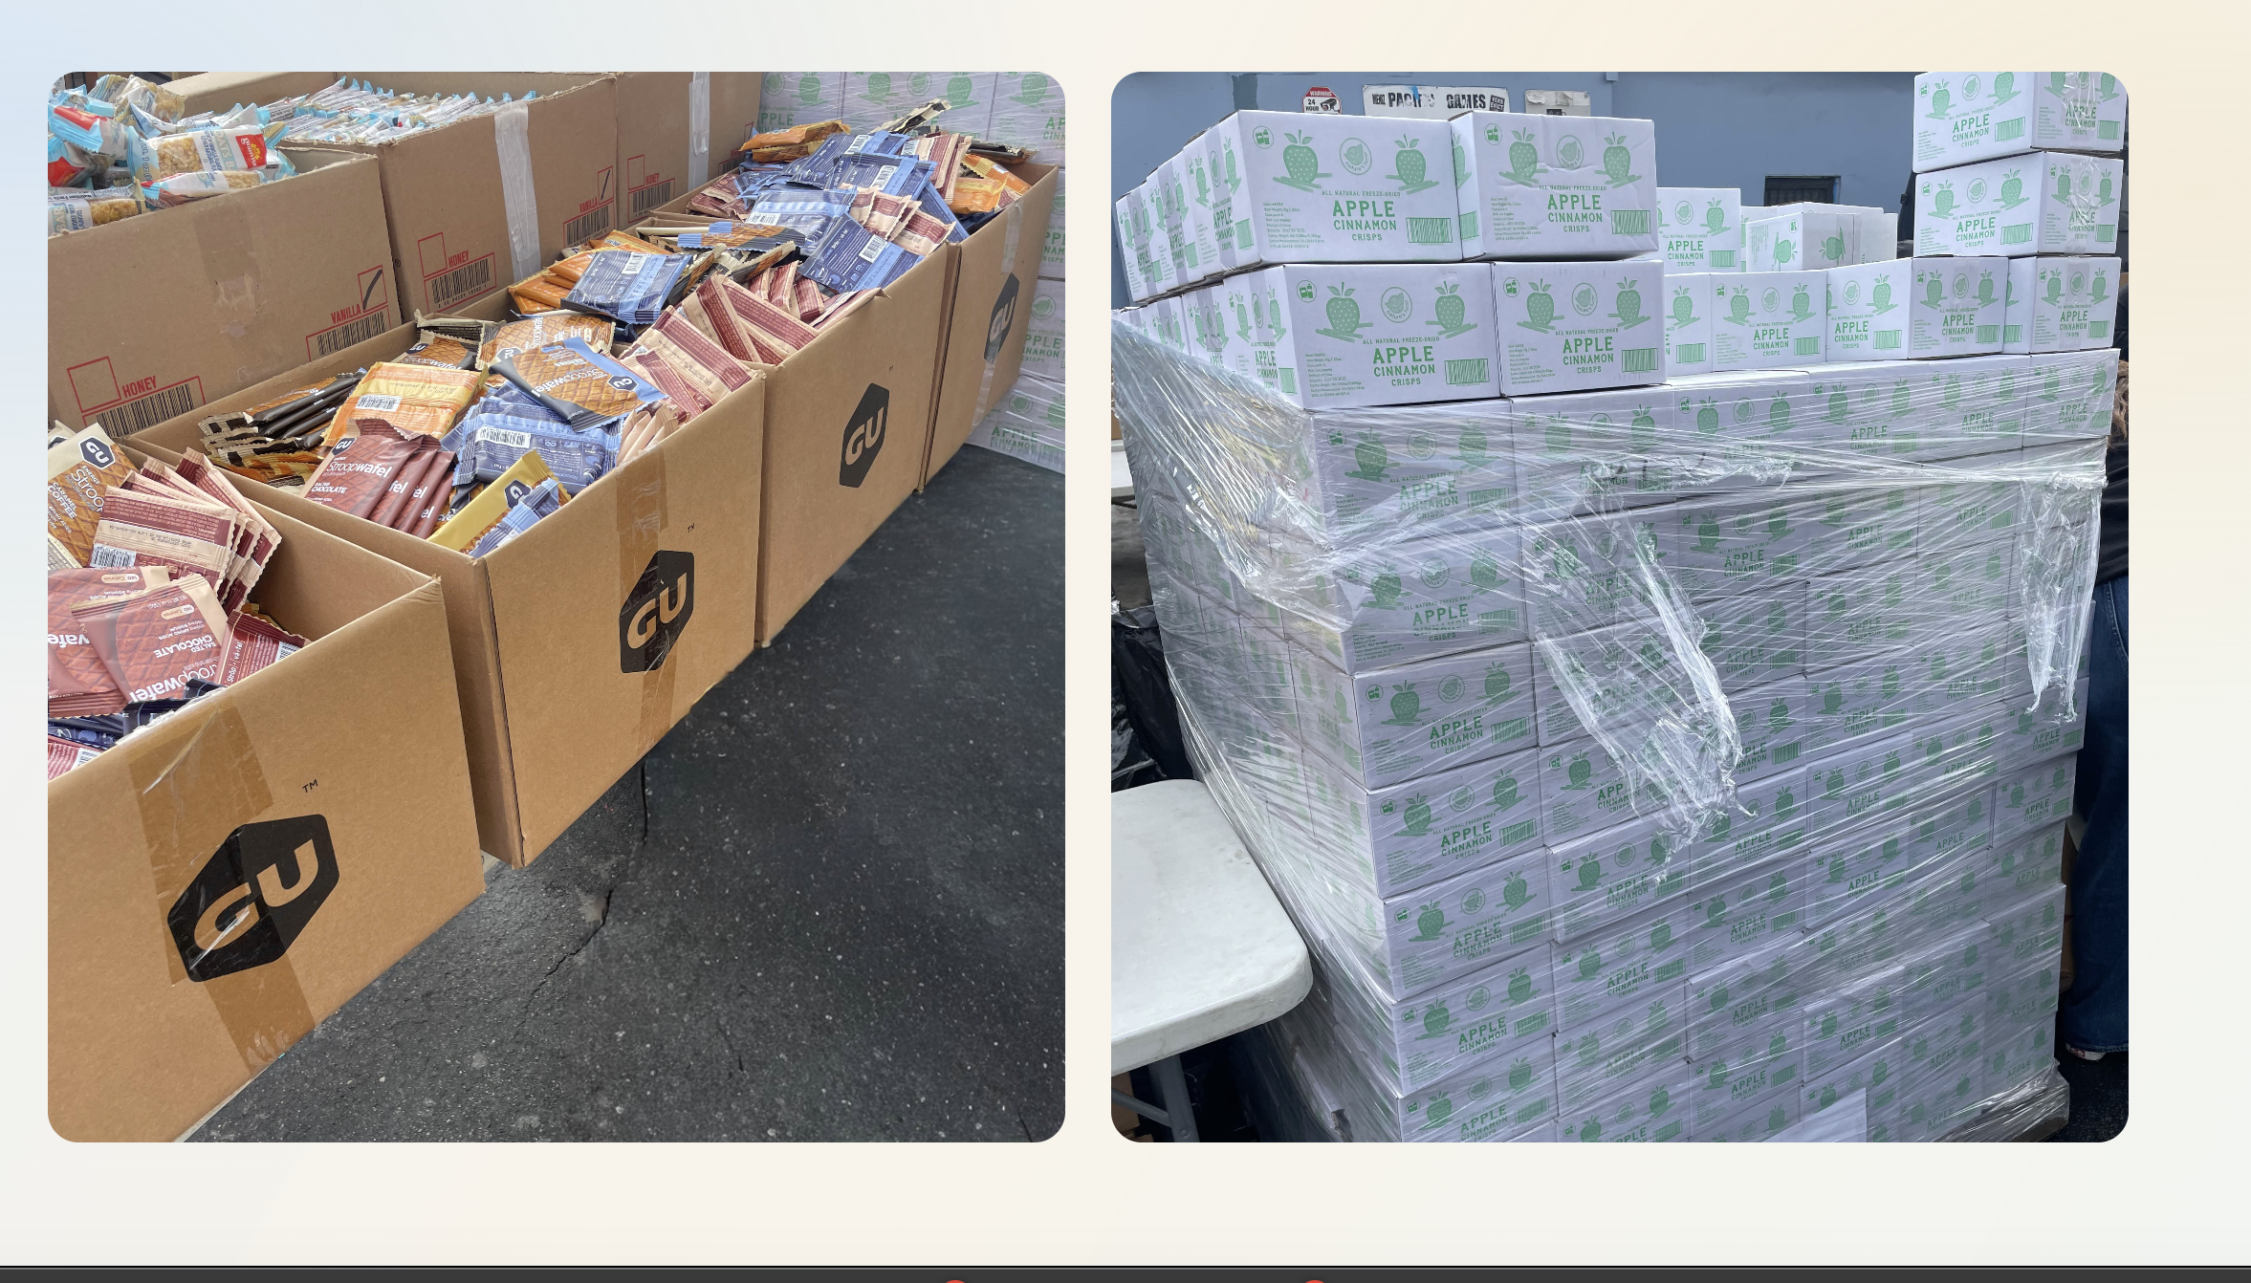
Can you include …. Skid Row, Los Angeles, CA …..just below these images?

